Type

Numbers

Decimal Numbers

Here, the table illustrates the type of numbers in Kotlin.

|  |  |  |  |  |
| --- | --- | --- | --- | --- |
| type | Bytes (it holds) | Signed or unsigned | Range | |
| Min Value | Max Value |
| Byte | 1 | unsigned | $$-2^{7}$$ | $$2^{7}-1$$ |
| Short | 2 | unsigned | $$-2^{15}$$ | $$2^{15}-1$$ |
| Int | 4 | unsigned | $$-2^{31}$$ | $$2^{31}-1$$ |
| Long | 64 | unsigned | $$-2^{63}$$ | $$2^{63}-1$$ |

Here, the table figure the type of numbers in Kotlin.

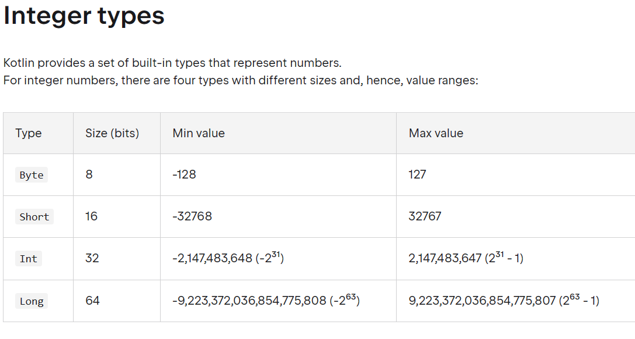

If you want to check or verified the Min Value and Max Value in the table and figure, you can use calculator and the formula we discussed in the Github.

[DigitalSystem/basic knowledgement/number/number range at main · 40843245/DigitalSystem · GitHub](https://github.com/40843245/DigitalSystem/tree/main/basic%20knowledgement/number/number%20range)

For more available info, see Kotlin Docs.

[Numbers | Kotlin Documentation (kotlinlang.org)](https://kotlinlang.org/docs/numbers.html#integer-types)